CURRICULUM VITAE
 |  | Dr. Yasir Awais Butt
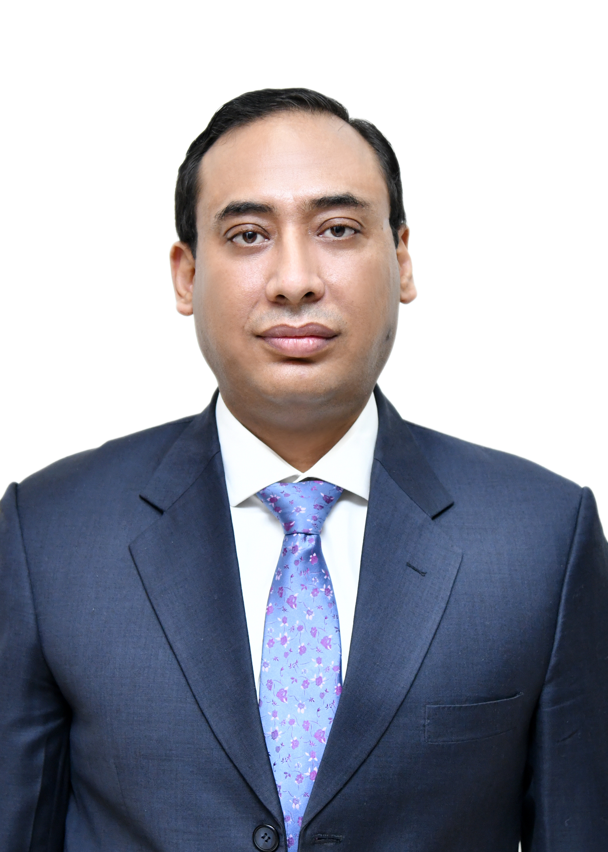 |  | Current Position: Associate Professor MCS, NUST Islamabad  Address: House # 675 Street 5 Chaklala Scheme 3 Rawalpindi  Telephone: 03235357125, 03325020368  PEC Membership: Professional Engineer, ELECT/34467  Email: yasir.aawais@mcs.nust.edu.pk, yasir.aawais@gmail.com
Objectives
To engage actively in research in control systems and make valuable contributions to international research arena thereby helping uplift my society through scientific research and education.
profile
Honest, confident and hardworking leader; a person of keen judgment with a record of integrity and dependability, poised to leverage education and experience toward launching research efforts in the field of control systems as tools of self-improvement and service to society.
Education
PhD Electrical Engineering (2015)
Muhammad Ali Jinnah University Islamabad, Pakistan
CGPA 4.0/4.0
MSc Computer Engineering (2011)
Centre for Advanced Studies In Engineering Islamabad, Pakistan
CGPA 4.0/4.0
BE Electrical Engineering (2001)
College of Electrical and Mechanical Engineering National University of Science and Technology Islamabad, Pakistan
CGPA 3.767/4.0

PhD Thesis | Sub-Riemannian Problem on Lie Group of Motions of Pseudo Euclidean Plane
Thesis Advisor | Professor Dr. Aamer Iqbal Bhatti, Muhammad Ali Jinnah University, Islamabad, Pakistan
Thesis Coadvisor | Professor Dr. Yuri L. Sachkov, Chief of Control Systems Laboratory, Program Systems Institute, Russian Academy of Sciences, Pereslavl Zalessky, Russia
Research Interests | Sub-Riemannian Geometry, Geometric control theory, Optimal Control Theory, Sliding Mode Control, Robotics Motion Planning and Control of Robots, Nonlinear Systems.
Honors and Awards
- Best final year project Gold Medal in BE on, "GPS Based Vehicle Tracking System"
- First position in National Championship of the Final Year Project Award (2022-2023), https://nutech.edu.pk/news/nutech-wins-ignite-national-championship-final-year-project-award/
supervisions
- FYDP – 4
- MS Thesis – 8
- PhD – 4
RESEARCH PUBLICATIONS
INTERNATIONAL CONFERENCE PUBLICATIONS
- Muhammad Faheem Manzoor, Yasir Awais Butt, Fazal-ur Rehman; Aamer Iqbal Bhatti, Fault-Tolerant Control of Fighter Aircraft using MPC, 19th International Bhurban Conference on Applied Sciences and Technology (IBCAST), August 2022
- Zeeshan Baber, Yasir Awais Butt, NMPC based Trajectory Tracking Control for Nonholonomic Wheeled Mobile Robot, Accepted for publication in 17th International Conference on Frontiers of Information Technology (FIT'19)
- H. M. Yasir Naeem, A. Iqbal Bhatti, Y. A. Butt and Q. Ahmed, "Velocity Profile Optimization of an Electric Vehicle with Battery Dynamic Model," 12th Asian Control Conference (ASCC), Kitakyushu-shi, Japan, 2019, pp. 609-614.
- F. Gulzar, Y. A. Butt, Z. M. Zeeshan, Design and manufacturing of Ku band detector, 15th International Bhurban conference on Applied Sciences and Technology (IBCAST), 2018
- G. Murtaza, Y. A. Butt, A. I. Bhatti, R. Anjum, FTC for air path actuators of a diesel engine using VGSTA, 13th International Conference on Emerging Technologies (ICET), 2017
- G. Murtaza, Y. A. Butt, A. I. Bhatti, R. Anjum, Higher order sliding mode based control scheme for air path of diesel engine, 12th International Conference on Emerging Technologies (ICET), 2016
- Yuri L. Sachkov, Yasir Awais Butt, Optimal synthesis for the left-invariant sub-Riemannian problem on the group of hyperbolic motions of the plane, Sixth International Conference on Geometry, Dynamics, Integrable Systems – GDIS 2016, Russia
- Yasir Awais Butt, Aamer Iqbal Bhatti, Exponential stabilization of kinematic nonholonomic systems using adaptive backstepping, ICET 2016, Islamabad
- Ghulam Murtaza, Aamer Iqbal Bhatti, Yasir Awais Butt, Higher order sliding mode based control scheme for air path of diesel engine, ICET 2016, Islamabad
- Yasir Awais Butt, Yuri L. Sachkov, Sub-Riemannian Problem on Lie Group SH(2), International Conference on Mathematical Control Theory and Mechanics, Suzdal, Russia, Jun 2015
- Yasir Awais Butt, Aamer Iqbal Bhatti, Yuri L. Sachkov, “Integrability by Quadratures in Optimal Control of a Unicycle on Hyperbolic Plane”, Accepted, American Control Conference, 1 – 3 Jul 2015, Chicago, Illinois,
- Yasir Awais Butt, Yuri L. Sachkov, Aamer Iqbal Bhatti, “Maxwell Strata and Conjugate Points in Sub-Riemannian Problem on Group SH(2)”, International Youth Conference on Geometry and Control, Moscow, April 14 – 18, 2014
- Yasir Awais Butt, Yuri L. Sachkov, Aamer Iqbal Bhatti, “Extremal Trajectories and Maxwell Points in Sub-Riemannian Problem on the Group SH(2)”, International Conference on Mathematical Control Theory and Mechanics, Suzdal, Russia, 5--9 Jul 2013
- Yasir Awais Butt, Aamer Iqbal Bhatti, “Robust altitude tracking of a helicopter using sliding mode control structure”, 2012 International Conference on Emerging Technologies, pages 1-7, October 2012
INTERNATIONAL JOURNAL PUBLICATIONS
- H. M. Y. Naeem, Q. Ahmed, Y. A. Butt, A. I. Bhatti, L. Qiu and X. Bai, "Optimizing Energy and Battery-Health Using Route, Allocation and Velocity Planning for a Multi-Electric Vehicle System," in IEEE Transactions on Transportation Electrification, doi: 10.1109/TTE.2025.3592834.
- Faheem Gulzar, Noor Muhammad Khan, Yasir Awais Butt, Aamer Iqbal Bhatti, Constraint-oriented Formation Control of Multi-robot System in Leaderless Consensus under Confined Conditions, Systems Science & Control Engineering, 12(1). https://doi.org/10.1080/21642583.2024.2436666
- Muhammad Faheem Manzoor, Joel A. Paulson, Yasir Awais Butt, Fazal-ur Rehman, Aamer Iqbal Bhatti, Real-Time Implementation of Nonlinear Model Predictive Control for High Angle of Attack Maneuvers in Fighter Aircrafts using Deep Learning, Systems Science & Control Engineering Journal (TSSC), Apr 2024, DOI 10.1080/21642583.2024.2342819
- Shaikh, J., Butt, Y. A., & Naqvi, H. F. (2024). Effective Intrusion Detection System Using Deep Learning for DDoS Attacks. The Asian Bulletin of Big Data Management, 4(1). https://doi.org/10.62019/abbdm.v4i1.113", Mar 2024
- Hafiz Muhammad Yasir Naeem, Bhatti, Aamer Iqbal, Yasir Awais Butt, and Qadeer Ahmed, Bai Xiaoshan, Energy Efficient Solution for Connected Electric Vehicle and Battery Health Management Using Eco-Driving Under Uncertain Environmental Conditions, Accepted for publication in IEEE Transactions on Intelligent Vehicles, Impact Factor 8.2,
- Bhatti, Aamer Iqbal, Hafiz Muhammad Yasir Naeem, Yasir Awais Butt, and Qadeer Ahmed. "Energy Minimization using Connectivity-based eco-Routing and Driving for Fleet of Battery Electric Vehicles”, "IEEE Transactions on Transportation Electrification". (IF:6.519), DOI: 10.1109/TTE.2023.3282240, Jun 2023
- Naeem, Hafiz Muhammad Yasir, Aamer Iqbal Bhatti, Yasir Awais Butt, and Qadeer Ahmed. "Optimal Control based Eco-driving Solution for Connected Battery Electric Vehicle on a signalized Route” Accepted by "Automotive Innovation", Springer Nature. (IF:1.99), Jun 2023
- Naeem HMY, Bhatti AI, Butt YA, Ahmed Q. Eco-driving control of electric vehicle with battery dynamic model and multiple traffic signals. Proceedings of the Institution of Mechanical Engineers, Part D: Journal of Automobile Engineering, Volume 236, Issue 6 https://doi.org/10.1177/09544070211037468, August 2021.
- G. Murtaza, A. I. Bhatti , Y. A. Butt, Unified FDI and FTC Scheme for Air Path Actuators of a Diesel Engine Using ISM Extended with Adaptive Part, Asian Journal of Control, July 2018
- G. Murtaza, A I. Bhatti, Yasir A Butt, Super twisting controller-based unified FDI and FTC scheme for air path of diesel engine using the certainty equivalence principle, Journal of Automobile Engineering Part D: Proceedings of the Institution of Mechanical Engineers, 2017
- Yasir Awais Butt, Robust stabilization of a class of nonholonomic systems using logical switching and integral sliding mode control, Alexandria Engineering Journal, https://doi.org/10.1016/j.aej.2017.05.017
- Yasir Awais Butt, Yuri L. Sachkov, Aamer Iqbal Bhatti, “Cut Time and Optimal Synthesis in the Sub-Riemannian Problem on the Lie Group SH(2)”, Journal of Dynamical and Control Systems, Published online August 5, 2016, DOI 10.1007/s10883-016-9337-4
- Yasir Awais Butt, Yuri L. Sachkov, Aamer Iqbal Bhatti, “Maxwell Strata and Conjugate Points in the Sub-Riemannian Problem on the Lie Group SH(2)”, Journal of Dynamical and Control Systems, Published online April 20, 2016
- Yasir Awais Butt, Yuri L. Sachkov, Aamer Iqbal Bhatti, “Extremal Trajectories and Maxwell Strata in Sub-Riemannian Problem on Group of Motions of Pseudo-Euclidean Plane”, Journal of Dynamical and Control Systems: Volume 20, Issue 3 (2014), 341-364
TEACHING EXPERIENCE
S No | Course title | university | level | Designation
 | Introduction to Mechatronics | CUST | Undergraduate | Visiting Lecturer
 | Probability Methods in Engineering | Abasyn University, Isb | Undergraduate | Visiting Lecturer
 | Power Systems Analysis | Abasyn University, Isb | Graduate | Adjunct Faculty – Assistant Professor
 | Sliding Mode Control | CUST | Graduate | TA
 | Control System Design | Abasyn University, Isb | Graduate | Adjunct Faculty – Assistant Professor
 | Nonlinear Systems | Institute of Space Technology | Graduate | Visiting Lecturer
 | Optimal Control Theory | Institute of Space Technology | Graduate | Visiting Lecturer
 | Nonlinear Systems and Control | Air University Kamra Campus | Graduate | Visiting Lecturer
 | Digital Logic Design | NUTECH | Undergraduate | Associate Professor
 | Statistical and Mathematical Methods in Data Science | Abasyn University | Graduate | Adjunct Faculty
 | Operating Systems | NUTech | Undergraduate | Associate Professor
 | AI and Machine Learning | NUTech | Undergraduate | Associate Professor
 | Digital Logic Design | MCS NUST | Undergraduate | Associate Professor
 | Embedded Systems | MCS NUST | Undergraduate | Associate Professor
 | Optical Fiber Communication | MCS NUST | Undergraduate | Associate Professor
MASTERS Thesis Supervised
- Sliding mode based robust control of a lower limb rehabilitation robot, 2018
- Particle swarm optimization based sliding mode control of a quadrotor UAV, 2019
PHD THESIS SUPERVISED
- Fault tolerant control of a diesel engine, 2019
- Velocity profile optimization of electric vehicle, In collaboration with Mr. Yasir Naeem
- Robust control of a highly agile aerospace platform with Mr Faheem Manzoor
TEACHING INTERESTS
- Mathematics
  - Single Variable Calculus
  - Multivariable Calculus
  - Differential Equations
  - Linear Algebra
  - Numerical Analysis
- Electrical Engineering
  - Electronics
  - Digital Logic Design
- Control Systems
  - Classical Control of Dynamic Systems
  - Linear Systems
  - Nonlinear Control Systems
  - Sliding Mode Control
  - Robust Control
  - LMI in Control
Current Projects
- Velocity profile optimization for all electric vehicle (In collaboration with Mr. Yasir Naeem – PhD Thesis)
- Safety and Resilience in Task Performance by Swarm of Robots (In collaboration with Mr Faheem Gulzar – PhD Thesis)
- Toothbrush Simulator Machine, Funded by Army Medical College, NUMS
- Poor Man’s Dental Diagnostic System using Deep Learning, FYP 24/25
- Teleoperated Prosthetic Hand, FYP 24/25
- Multi modal academic content effectiveness rating system using deep learning, MS Thesis/ Project
- Multilingual dubbing solution for content generation platform
- Virtual try on system using stable diffusion, control net and concatenation techniques
- Optimal Dynamic Task Allocation for a Multi-Robot System Operating Under Environment Constraints and Safety Requirements using Control Barrier Functions, Funding proposal in collaboration with KFUPM
- Reverse engineering of BLDC motor controller for local fan industry

